Green Group
Alexander Baldree
Jordan Dardar
Maksymilian Jankowski
Aftabur Rahman
12/5/25
CSD310 Milestone #2
GitHub Link:
https://github.com/Panda-Alex21687/Green-Group
ERD Outland:

Visual Studio Output:
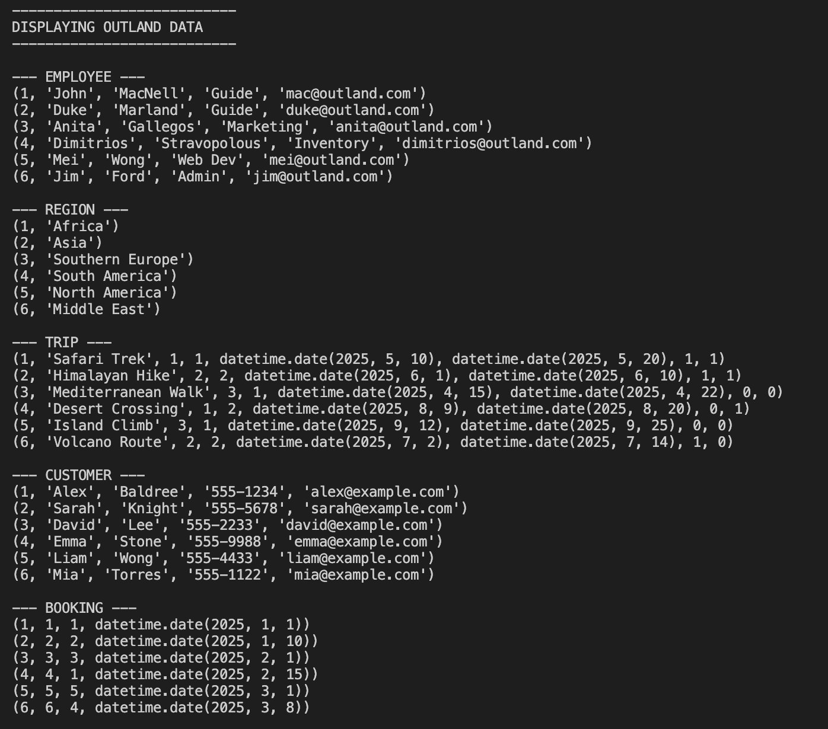
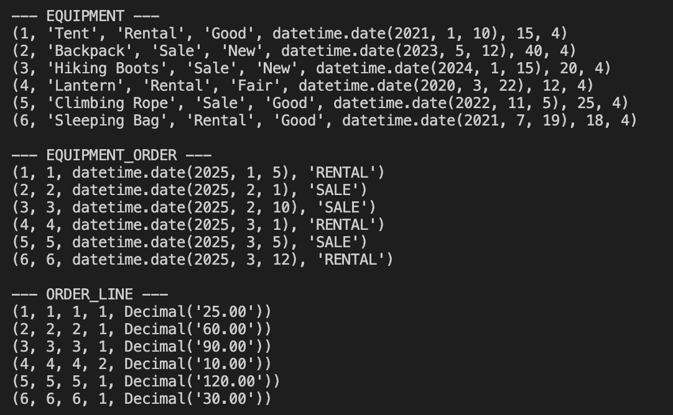

Booking:
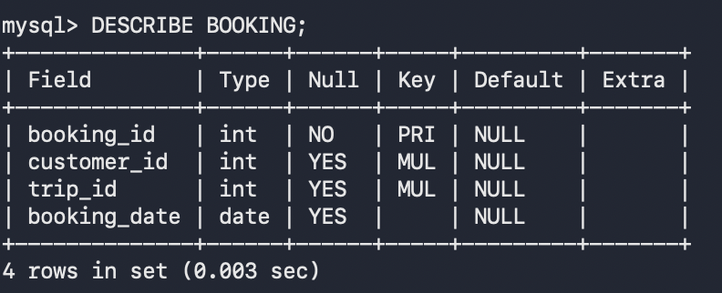

Customer:
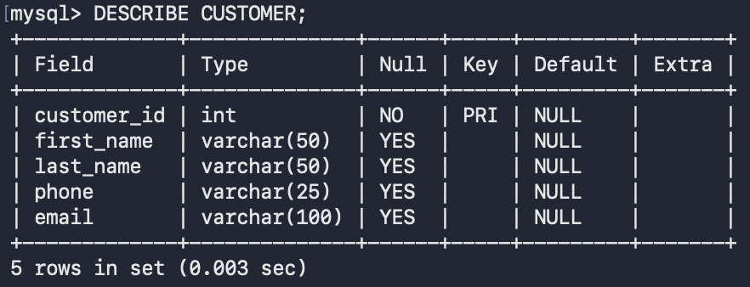

Employee:
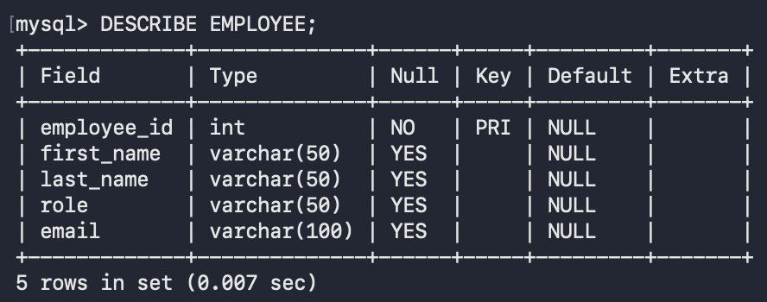

Equipment:
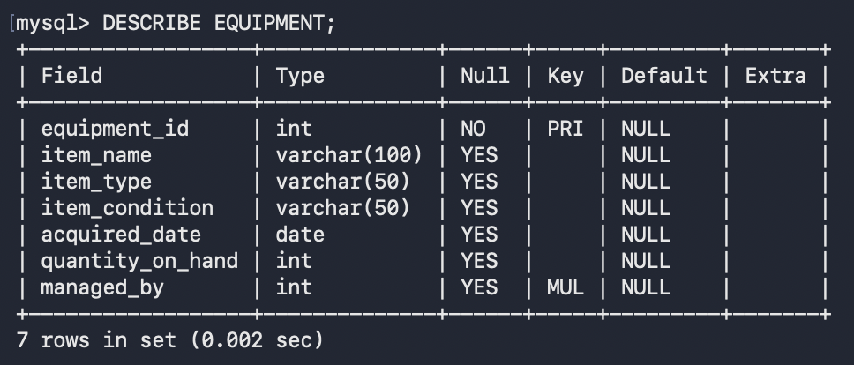
Equipment_Order:
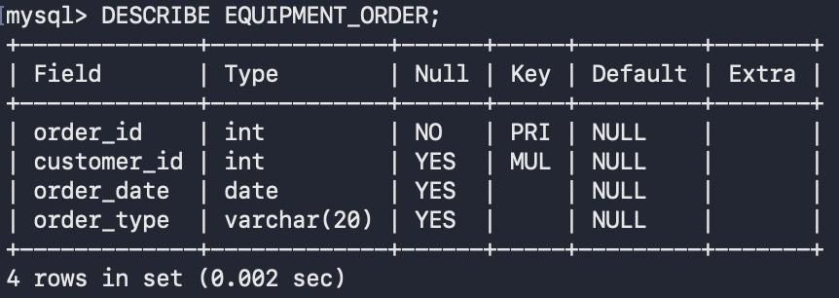
Order_Line:
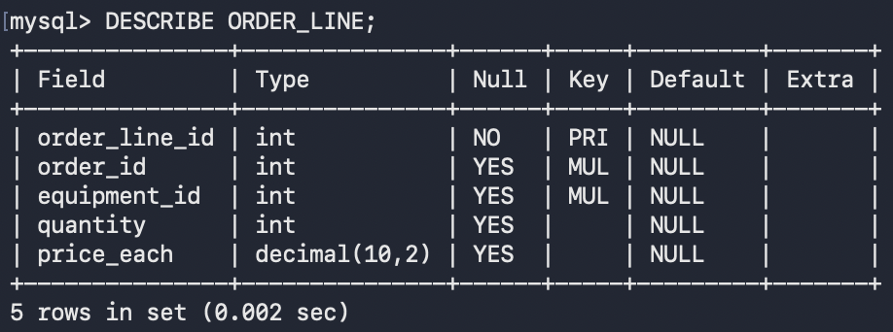
Region:
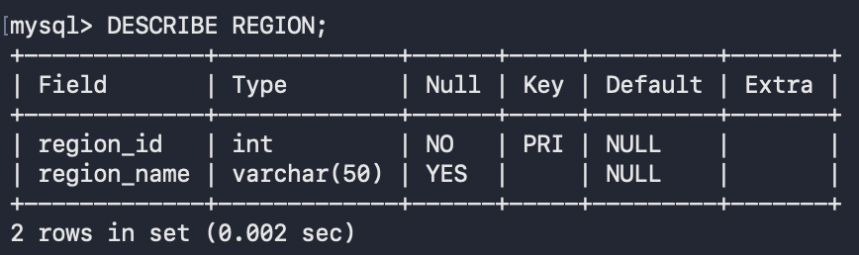

Trip:
